Random Variables

Random Variables

The numerical description of the outcome of a statistical experiment is called a random variable. In other words, a random variable is a set of possible numerical values in a random experiment. Also can be said a random variable is the result of a random experiment, such as tossing a coin, rolling a die, picking a number from a designated interval.

**📝Random Variable**  
When the value of a variable is the outcome of a statistical experiment , that variable is a random variable.

The idea behind the random variable is that you get a sample of the random variable, each time you repeat the experiment. You expect to get different values as you get multiple samples because the variable is random. However, some values might be more likely than others, as in the case of rolling two six-sided die and recording the sum of the resulting two numbers, where getting a value of 5 is much more probable than getting a value of 12.)

A random variable can be continuous, such as in the result of randomly selecting a number between 0 and 1. In this case, a random variable can take any real number from 0 to 1, where each number would be equally probable.

A random variable can also be discrete, such as in the result of the rolling a die. In this case, a random variable can take a value from the set {1,2,3,4,5,6}, each with the probability of 1/6.

## Random Variables

### Probability Distributions

Probability Distribution is a statistical function, listing all possible results that a random variable can take. By showing all possible values that a random variable can take with the probability of these values, it gives an idea about the underlying probability distribution.

**📝Probability Distribution**  
A probability distribution is a table or an equation that links each outcome of a statistical experiment with its probability of occurrence.

For example, you draw a random sample and measure the heights of the subjects. You can form a distribution of heights as you measure the heights. This distribution is useful when you need to know which results are more likely, the spread of possible values, and the likelihood of different outcomes.

As you remember a random variable can be either continuous or discrete. The dispersion of the values of a random variable is described by probability distributions. Therefore, the type of a variable determines the kind of probability distribution. Probability Distributions are divided into the following two types:

* [Discrete probability distributions](https://lms.clarusway.com/mod/lesson/view.php?id=1878) for discrete variables,
* [Continuous probability distributions](https://lms.clarusway.com/mod/lesson/view.php?id=1879) for continuous variables.

## Discrete Probability Distributions

### Introduction

Each possible value has a non-zero likelihood for discrete probability distribution functions. Besides, the sum of the probabilities of all possible values is equal to one. One of the values must occur for each experiment because the total probability equals to one. For example, while rolling a die, the chance of rolling a particular number on a die is 1/6. However, the total probability is one. You inevitably get one of the possible values when you roll a die.

There are several discrete probability distributions. Here we will discuss about Bernoulli, Binomial and Poisson distributions under the discrete probability distributions.

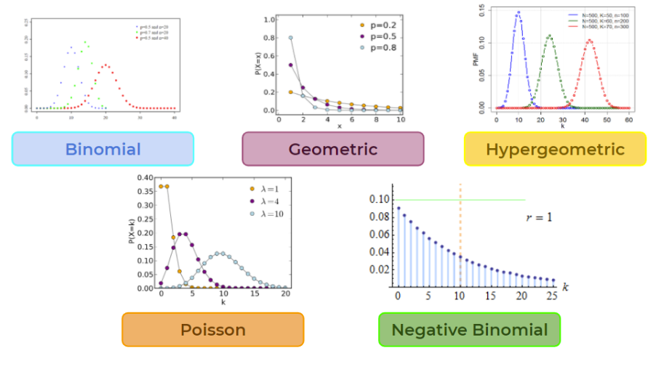

## Discrete Probability Distributions

### Binomial Distributions

Because the prefix “bi” means two, the binomial is a type of distribution that has two possible outcomes.

It can be thought of as simply the probability of a **success** or **failure** outcome in an experiment that is repeated several times. A coin toss that has only two possible outcomes is a good example of binomial distributions. Another example is can be given as taking a test that could have two possible outcomes: **pass** or **fail**.

**Tips:**

* The binomial distribution relates to multiple trials. Instead of multiple trials, if there is a single event and if this event has two possible outcomes you should consider Bernoulli distribution which we will discuss later.

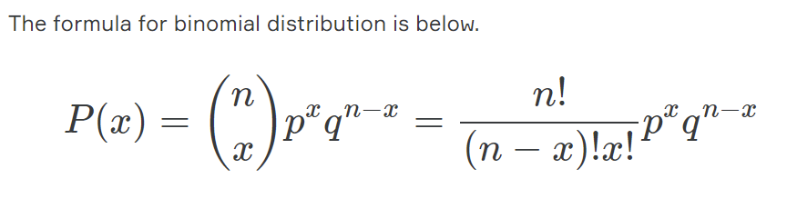

n= number of trials  
x=number of successes desired  
p=probability of getting success in one trial  
q=1-p (probability of getting failure in one trial)

The first variable in the binomial formula, n, stands for the number of trials. If you flipped a coin 100 times, then n is 100. The second variable, p, represents the probability of one specific outcome. Therefore, while flipping o coin the probability of getting tails is 0,5. That means if you flip a coin 100 times you have a binomial distribution of n=100, p=1/2. Success would be “to get tails” and FAILURE would be “to get heads”. The variable x is the number of success desired. Binomial distribution gives us the probability of success for each x value. For example probability of zero time success (which is close to zero), one time, two times, three times,... and 100 times successes (which is also close to zero). The variable x changes from zero to n in a binomial distribution.

**Tips:**

* Binomial distributions can be used to model the following situations:  
  - The performance of a machine learning model.  
  - Number of patients responding to a treatment.

## Discrete Probability Distributions

### Practice Binomial Distributions

Suppose you flip a fair coin three times. What is the chance of getting two tails? In that case, getting tails is a success, getting heads is a fail. We will flip three times, so n=3. We will find the probability of two successes, so we can say x=2. Because we will flip fair coins probability of getting tails is 0,5, in other words, p=0,5. If you put all these variables in the formula you will calculate the probability of getting two tails as 3/8. Let's prove it now. Possible outcomes after three toss are below.

HHH, HHT, HTH, HTT, THH, THT, TTH, TTT

Two tails" could be in any order: "HTT", "THT" and "TTH" all have two tails (and one head).

So three of the 8 outcomes produce "Two Tails".

Flipping a coin three times can get any of these 8 outcomes. So the probability of the event "Two Tails" is 3/8. That means P(X=2)=3/8.

What about other possible options. Taking the all possible outcomes into consideration (HHH, HHT, HTH, HTT, THH, THT, TTH, TTT) we can say that:

P(X=0)=1/8

P(X=1)=3/8

P(X=2)=3/8

P(X=3)=1/8

If we plot these results, we obtain a symmetrical binomial distribution. It gives us the probability of success for each x value. For example, the probability of getting no tails after three trials is 1/8, or the probability of getting three tails is also 1/8. The picture below shows the distribution.

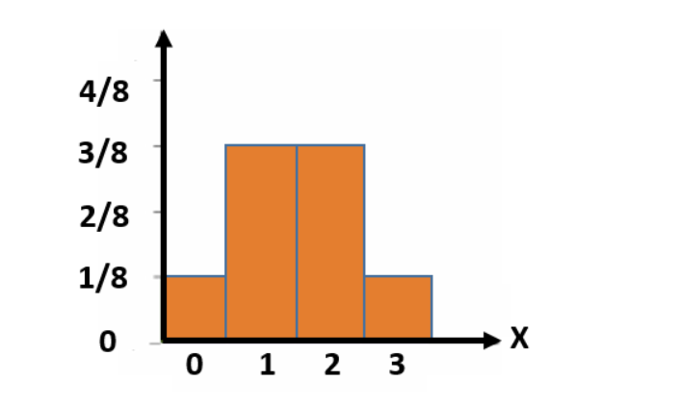

## Discrete Probability Distributions

### Bernoulli Distributions

It is a special case of the binomial distribution where "n" is equal to one. In other words, it is a binomial distribution with a single trial. Therefore, bernoulli distribution is also a discrete distribution and has only two outcomes like binomial distribution. The formula is:

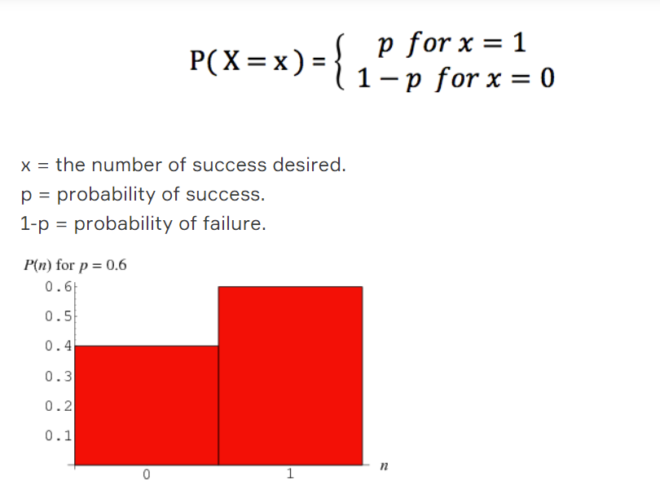

**Tips:**

* Bernoulli distributions can be used to model the following situations:  
  - A newborn child is either male or female.  
  - Either to pass or fail an exam.  
  - A tennis player either wins or loses a final.  
  - People like something or not.

## Discrete Probability Distributions

### Practice Bernoulli Distributions

Suppose you want to know how many people in your city like honey. You can’t survey the entire city, but you might survey only the people in your apartment, using them as a sample. You ask them whether or not they like honey, and you describe “liking honey” as a success, and “disliking honey” as a failure. Suppose you found that %80 of your neighbors like honey. That means %20 of them to dislike honey because the total probability must be equal to one for both binomial and Bernoulli distributions.

We can represent this in a bernoulli distribution like in the following picture:

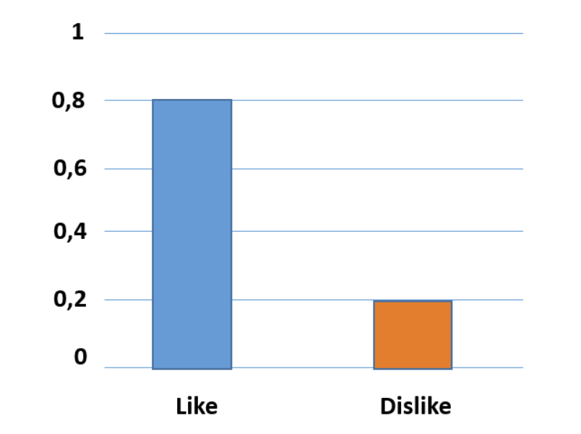

This picture represents a classical Bernoulli distribution. There are two separate columns and the sum of the probabilities of these columns equal to one.

Discrete Probability Distributions

Poisson Distributions

A Poisson distribution is used to predict the probability of events that are rarely encountered in a particular area during a given time interval.

For example, rent a car office rents an average of 20 cars every weekend. Considering this data, you can predict the probability of renting more cars, perhaps 30 or 40 cars at the following weekend.

Another example is the number of customers in a hotel every day. If the average number of customers for seven days is 250, you can predict the probability of a certain day having more customers.

**💡Tips:**

* Poisson distributions can be used to model the following situations:  
  - Number of errors in a book,  
  - Number of delayed flights,  
  - Credit card fraud detection.

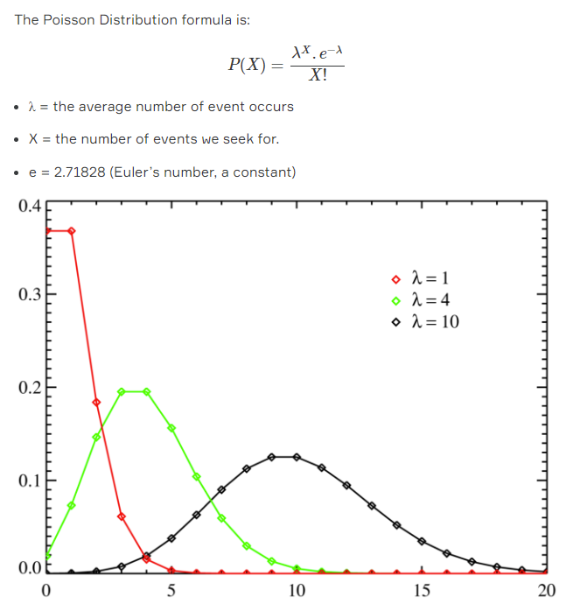

## Discrete Probability Distributions

### Practice Poisson Distributions

The average number of major floods in a city is 3 per year. What is the probability that exactly 4 floods will occur in this city next year?

λ = 3 (average number of floods per year, historically)

x = 4 (the number of floods we think might for the next year)

e = 2.71828 (Euler’s number, a constant)

If we put all these variables in the formula:

